**IoT BASED SAFETY GADGET FOR CHILD SAFETY MONITORING AND NOTIFICATION**

Project Development –Delivery of Sprint 3

**Creating Cloudant DP, MIT App and connect with NODE RED**

**Team ID:** PNT2022TMID50776

Create cloudant DP

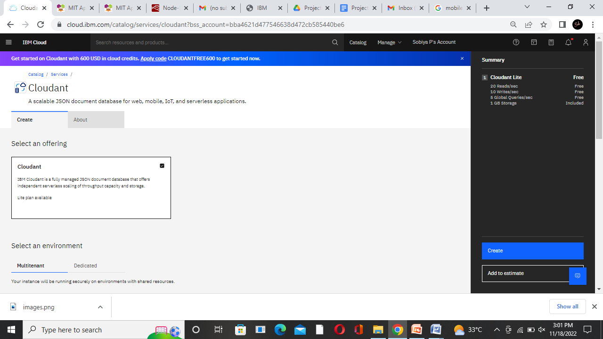

Connecting with NODE RED

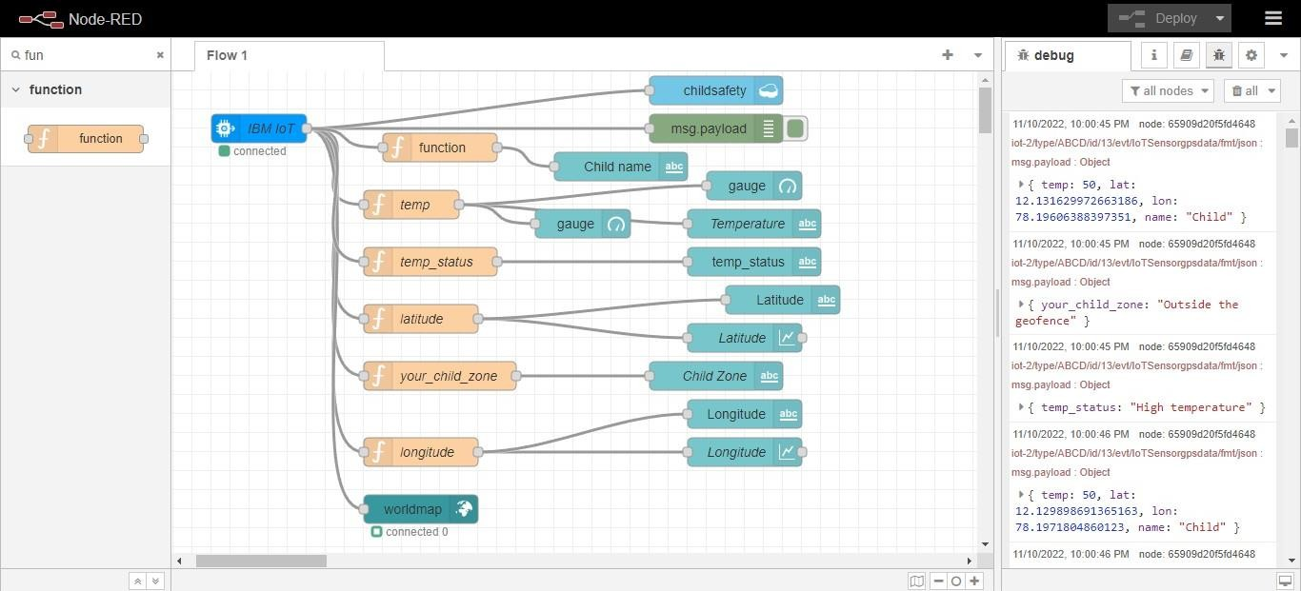

Creating MIT App

